**GenAI**

**CA-II**

**Assignment**



**Name: Aryan Verma**

**PRN: 21070521121**

**Section: B**

**Q: 1 Generate a model in Python to represent a Housing loan scheme and create a chart to**

**Display the Emi based on rate of interest and reducing balance for a given period. If a customer**

**Wishes to close the loan earlier, print the interest lost distributed over the remaining no. Of**

**Months. Assume suitable data and inputs as necessary.**

**Solution:** Flowchartto understand the flow of solution for the problem statement given.

**START**

**Initialize Loan:  
principal, rate_of_interest, tenure_months**

**Calculate EMI using formula**

**Generate EMI Chart**

**Calculate remaining balance  
after specified months**

**Calculate interest lost  
due to early closure**

**Display EMI,  
remaining balance,  
interest lost**

**END**

**Code:**

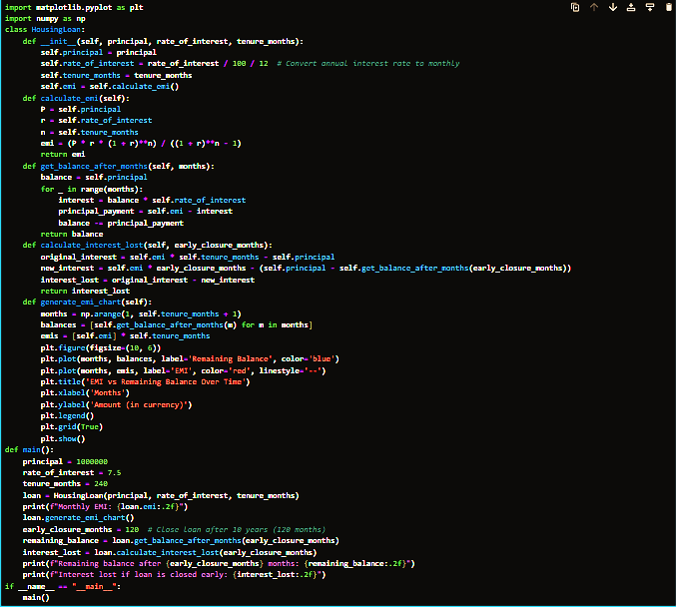

**Output:**

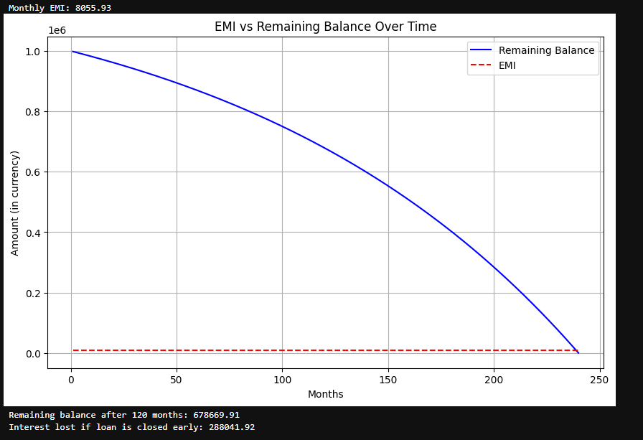

**Q: 2 Generate a model to represent a mathematical equation, write a program to parse the**

**Equation, and ask for input for each parameter.**

**Solution:** Flowchartto understand the flow of solution for the problem statement given.

**START**

**Print “Solving f(x,y)=ax^2+by+c”**

**Get user input (a,b,c,x,y)**

**Valid input?**

**No**

**Yes**

**Print “Invalid input” and return**

**Solve equation: ax^2 + by+ c**

**Print the result of the equation**

**END**

**Code:**

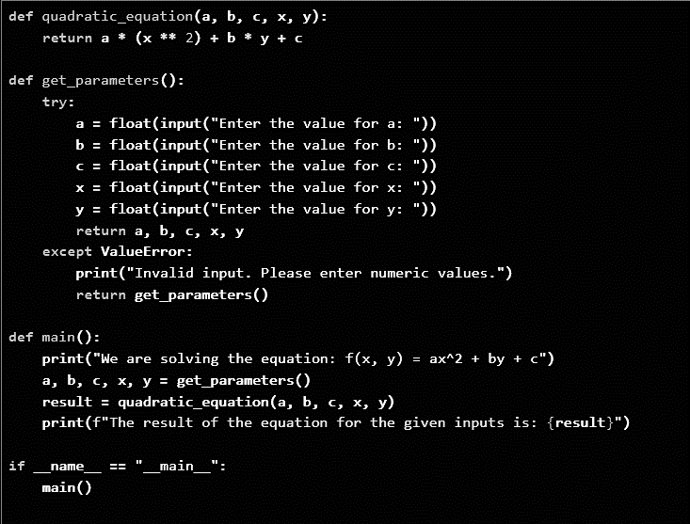

**Output:**

